  

INTERNSHIP REPORT

SUMMER INTERNSHIP PROGRAM – 2025

**Reduced Graphene Oxide (rGO) based Conductometric Sensors for Drinkable Water Quality Monitoring**

**SOHAM KANTI PAIRA**

**(T91/ECE/224085)**

Under the Guidance of

**Dr. Sayan Dey**

**Assistant Professor**

**Indian Institute of Technology Bhubaneswar**

**ACKNOWLEDGEMENT**

I am deeply grateful to my guide, **Dr. Sayan Dey**, Assistant Professor at the Indian Institute of Technology Bhubaneswar for his exceptional guidance and support throughout the course of my internship. I had the chance to work on complex research issues and acquire important knowledge of useful scientific approaches while he was my mentor at the IIT, School of Electrical and Computer Science Engineering - **Micro-Fabrication and Characterization Laboratory**. He always provided constructive criticism, fostered an atmosphere of learning and intellectual development, and was friendly, understanding and supportive. His knowledge and dedication significantly enhanced my research experience, for which I am still very grateful.

I also want to express gratitude towards my professors at the Institute of Radio Physics and Electronics, University of Calcutta - my home institution, for allowing me to participate in this kind of totally immersive out-of-station internship opportunity which helped me gain practical knowledge and technical abilities.

**CONTENTS**

**Serial No. Title Page No.**

1. **Acknowledgement 2**
2. **Abstract 4**
3. **Introduction 5-6**
4. **Literature Review 6-9**
5. **Workflow 9**
6. **Synthesis of Materials 10-13**
7. **Fabrication of the Device 13-16**
8. **Structural and Morphological Characterization 16-19**
9. **Electrical Characterization 19-24**
10. **Conclusion 24**
11. **Future Scope of Work 25**
12. **Limitations 25-26**
13. **References 27**

**Reduced Graphene Oxide (rGO) based Conductometric Sensors for Drinkable Water Quality Monitoring**

***Abstract:*** Ensuring the safety of drinking water requires reliable, cost-effective, and scalable monitoring systems. Conventional techniques suffer from high costs and operational complexity. This work addresses these limitations by developing a conductometric sensor based on a heterojunction of reduced graphene oxide (rGO) and molybdenum disulfide (MoS₂). The complementary properties of rGO—high electrical conductivity and mechanical strength—and MoS₂—a tuneable bandgap semiconductor with a high surface-to-volume ratio—make this material combination ideal for sensitive water quality sensing.

During this internship, graphene oxide was synthesized via modified Hummer’s method and reduced thermally to rGO, while MoS₂ nanosheets were produced using liquid-phase exfoliation in aqueous ammonia. Sequential drop-casting was used to fabricate the rGO–MoS₂ heterojunction sensor, which was structurally validated using X-ray diffraction and FESEM imaging. Electrical characterization through a four-probe cryogenic probing station confirmed the formation of a p–n junction, responsible for the sensor's enhanced electrical response.

The sensor operates by modulating resistance at the rGO–MoS₂ interface upon analyte interaction, leveraging MoS₂’s high surface activity and rGO’s superior conductivity for efficient signal transduction. Future work will focus on improving reproducibility, understanding the sensing mechanism in detail, and expanding detection capabilities. This study contributes towards the development of compact, low-cost sensors for real-time water quality monitoring.

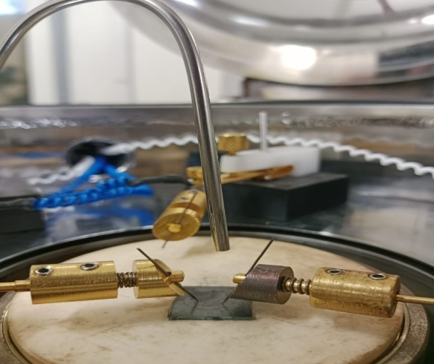

**Fig. 1: Probing of the rGO-MoS2 device for Electrical Characterization**

**3. INTRODUCTION:**

**3.1 Background and Motivation:**

Access to safe drinking water is a critical global need, yet conventional water quality monitoring technologies remain limited by high costs, complexity, and restricted scalability. Existing sensors often rely on expensive materials or intricate fabrication methods, making them unsuitable for widespread, real-time deployment, especially in resource-limited areas. Additionally, many traditional sensors lack the sensitivity or responsiveness required for early detection of contaminants in drinking water systems.

This project is motivated by the potential of two-dimensional (2D) materials like reduced graphene oxide (rGO) and molybdenum disulfide (MoS₂) to address these limitations. Their unique structural and electronic properties enable the development of compact, sensitive, and cost-effective sensors. By leveraging the formation of a heterojunction between rGO and MoS₂, the proposed sensor aims to provide real-time, reliable water quality monitoring. Such technology could play a significant role in improving public health standards, enabling decentralized water monitoring, and reducing the risks associated with contaminated drinking water.

**3.2 Objective of the Project:**

The objective of this project is to develop a cost-effective, scalable, and highly sensitive conductometric sensor based on a reduced graphene oxide (rGO) and molybdenum disulfide (MoS₂) heterojunction for real-time drinking water quality monitoring. This involves the synthesis of high-quality two-dimensional materials, fabrication of a hybrid sensor device, and extensive structural, morphological, and electrical characterization to evaluate the sensor’s performance and potential for practical deployment.

**3.3 Scope of the Report:**

This report outlines the complete process of developing an rGO–MoS₂ based heterojunction sensor for water quality monitoring. It covers the background and motivation behind selecting two-dimensional materials, detailed synthesis procedures, fabrication methodology, and characterization techniques used to evaluate the sensor’s structural, morphological, and electrical properties. The report also discusses the device’s sensing mechanism, its potential applications, limitations, and future research directions aimed at improving sensor performance and expanding its usability.

**3.4 Significance and Impact:**

The development of this heterojunction-based sensor holds significant potential for improving drinking water safety through real-time, low-cost, and scalable monitoring solutions. By utilizing readily available materials and simple fabrication techniques, this sensor can be deployed in both urban and rural settings, enabling widespread access to water quality data. Its enhanced sensitivity and rapid response contribute to early detection of contaminants, reducing health risks and supporting environmental monitoring efforts, making it a valuable tool for public health and sustainable water management.

**4. LITERATURE REVIEW:**

**4.1 Overview on Graphene Oxide:**

Graphene oxide (GO) is a derivative of graphene, composed of single-atomic layers of carbon atoms arranged in a hexagonal honeycomb structure, but functionalized with oxygen-containing groups such as hydroxyl, epoxy, and carboxyl. These oxygen groups disrupt the sp² hybridized carbon network, introducing defects and rendering GO hydrophilic, which improves its dispersion in water and other solvents [2]. GO retains many of graphene’s desirable properties, such as high mechanical strength and large surface area, while offering additional chemical versatility due to its functional groups.

However, GO itself is electrically insulating or exhibits limited conductivity due to the disruption of the conjugated π-system. To restore electrical conductivity while retaining functional versatility, GO can be reduced chemically or thermally to form reduced graphene oxide (rGO). rGO exhibits significantly improved electrical conductivity and retains some of the oxygen functionalities, making it suitable for applications requiring both conductivity and chemical interaction sites [1,3]. Due to its scalable synthesis via methods like the modified Hummer’s method [9], GO serves as a practical precursor for producing rGO-based hybrid composites, widely researched for sensors, energy storage, and environmental applications [4,5].

**4.2 Overview on Reduced Graphene Oxide (rGO):**

Reduced graphene oxide (rGO) is produced by removing oxygen-containing functional groups from graphene oxide (GO) through thermal, chemical, or electrochemical reduction processes. This reduction process restores the conjugated π-network of graphene, significantly enhancing its electrical conductivity while retaining a portion of its oxygen functionalities. The presence of residual functional groups allows rGO to retain good dispersibility and chemical reactivity, making it highly versatile for various applications [1,2].

rGO is preferred in sensor applications due to its combination of high electrical conductivity, large surface area, and ease of production. Unlike pristine graphene, which often requires complex and expensive synthesis methods like chemical vapor deposition (CVD), rGO can be synthesized cost-effectively from GO via scalable reduction techniques [3]. Its conductive network facilitates efficient charge transport, which is critical in sensors for rapid and sensitive signal transduction. Additionally, rGO’s residual oxygen groups provide active sites for chemical functionalization, enhancing interaction with analytes and improving sensor response [4,5]. For these reasons, rGO is widely used as a conductive layer in hybrid sensors, especially when combined with semiconducting materials like TMDs (Transition Metal Dichalcogenides) to form heterojunctions that further enhance sensing performance.

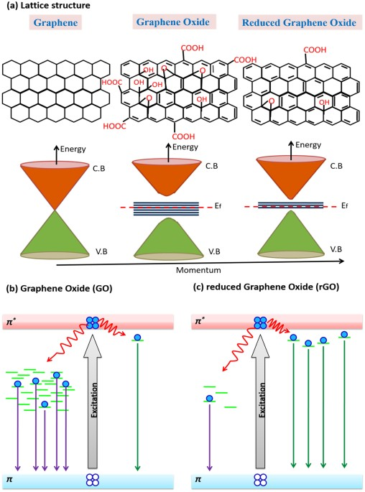

**Fig. 2: Lattice structure and band gap of Graphene, GO and rGO [1]**

**4.3 Receptor Layer Material - Transition Metal Dichalcogenide (TMD):**

Transition Metal Dichalcogenides (TMDs) are a class of layered two-dimensional materials with the general formula MX₂, where M is a transition metal (e.g.: Mo, W) and X is a chalcogen atom (e.g., S, Se). TMDs like molybdenum disulfide (MoS₂) exhibit semiconducting behaviour with a tuneable bandgap ranging from 1.2 to 1.9 eV, depending on the number of layers. Their high surface-to-volume ratio, chemical stability, and strong adsorption properties make them highly suitable as receptor layer materials in sensing applications. In particular, MoS₂ provides abundant active sites for analyte interaction and its semiconducting nature enhances charge modulation at the heterojunction interface, improving the sensitivity and selectivity of the sensor.

**4.3.1 Key Points:**

* Stable substance
* Wide temperature range functionality
* High surface to volume ratio [6]

**4.3.2 Molybdenum Disulphide (MoS2):**

Molybdenum disulfide (MoS₂) is specifically chosen over other TMDs due to its optimal balance of electronic properties, chemical stability, and availability. Unlike some TMDs that are metallic or have very narrow bandgaps, MoS₂ exhibits a direct bandgap in monolayer form and an indirect bandgap in multilayer form, enabling tuneable semiconducting behaviour critical for sensor applications. Its well-documented synthesis methods, high surface-to-volume ratio, and strong sulphide linkages facilitate efficient carrier transport and enhance analyte interaction. Additionally, MoS₂ nanosheets are relatively easy to exfoliate, chemically stable in aqueous environments, and cost-effective compared to alternatives like WS₂ or MoSe₂, making them a practical and reliable choice for the receptor layer.

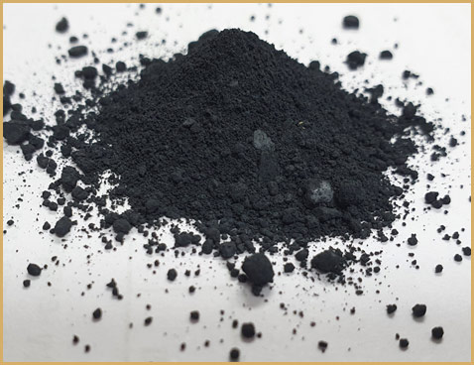 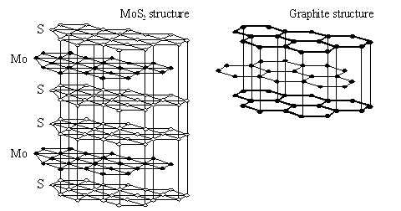

**Fig. 3: MoS2 powder and structure and its comparison with graphite structure**

**4.4 Key Findings:**

* p-type characteristics were mainly originated from predominant contribution of rGO sheets to overall conductivity. [10]
* Annealing at temperatures of 300–450 °C and 800–1000 °C gives n-type rGO, temperatures of 450–800 °C and below 300 °C gives p-type rGO. [11]
* Resistance of the device after MoS2 introduction became much larger which verified poor conductivity of MoS2 and the formation of p–n junction between p-type rGO and n-type MoS2. [10]
* Schottky type I-V curve due to formation of heterojunction. [10]
* Creation of p–n junctions can enhance the sensor response through changing the width of space–charge layer. [12]

**5. WORKFLOW:**

The workflow of this project involved synthesizing graphene oxide (GO) via modified Hummer’s method and reducing it thermally to form conductive reduced graphene oxide (rGO). Molybdenum disulfide (MoS₂) nanosheets were prepared using liquid-phase exfoliation in aqueous ammonia. The sensor device was fabricated by sequentially drop-casting rGO and MoS₂ layers onto a glass substrate, forming a heterojunction structure. Structural and morphological characterization was performed using XRD and FESEM, while electrical performance was evaluated through I–V measurements using a four-probe cryogenic probing station to assess the sensor’s response and efficiency.

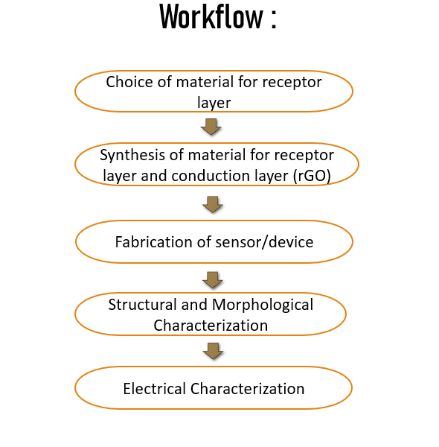

**6. SYNTHESIS OF MATERIALS;**

**6.1 Synthesis of GO using modified Hummer’s Method [9]:**

Graphene oxide (GO) was synthesized using the modified Hummer’s method in the following steps:

* **Sample Measurement:**  
  A precise amount of graphite powder was measured and prepared for oxidation.
* **Mixing and Stirring:**  
  The graphite powder was mixed with sodium nitrate (NaNO₃) and concentrated sulfuric acid (H₂SO₄). This mixture was stirred constantly to ensure uniform dispersion of reactants.
* **Addition of KMnO₄:**  
  Potassium permanganate (KMnO₄) was slowly added to the reaction mixture under continuous stirring to prevent excessive heat generation. This step was performed carefully to avoid overheating, keeping the temperature below 20°C.
* **Water Bath Heating:**  
  The solution was then placed in a water bath and heated to around 35°C to facilitate oxidation, maintaining constant stirring during this stage.
* **Dilution and Neutralization:**  
  After the oxidation reaction, deionized (DI) water was added to dilute the mixture, followed by the addition of hydrogen peroxide (H₂O₂) to neutralize any remaining KMnO₄. This resulted in a change in the solution’s colour indicating successful oxidation.
* **Filtration:**  
  The final solution was filtered to remove larger graphite oxide aggregates and unreacted residues. Filtration ensured a stable GO suspension suitable for uniform drop-casting during sensor fabrication.

Each step was performed carefully, controlling both time and temperature as specified in the procedure to obtain high-quality GO with minimal impurities.

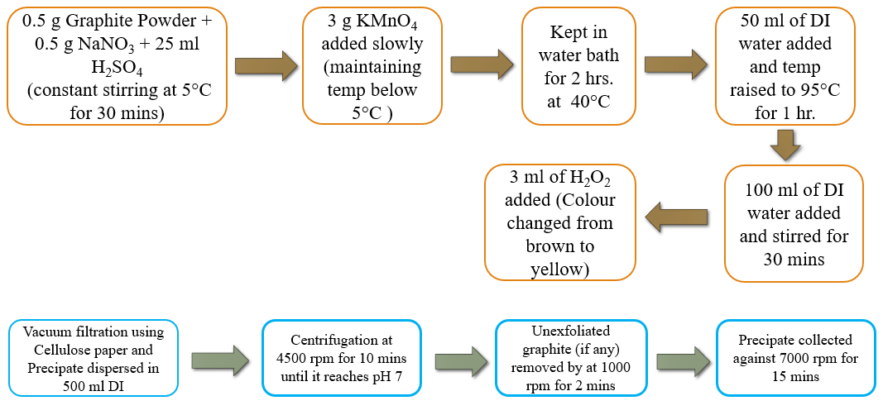

**Fig. 4: Flowchart explaining the synthesis of GO using modified Hummer’s Method**

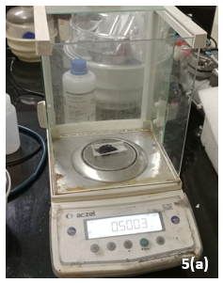 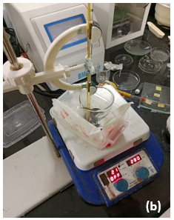 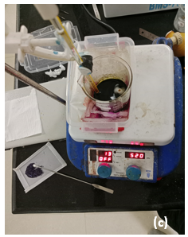

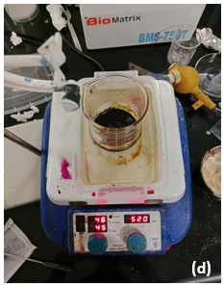 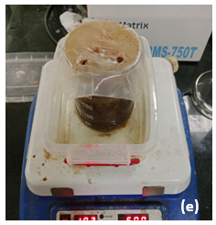 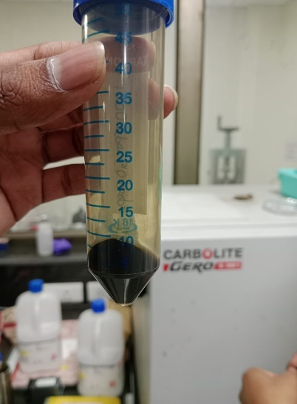

**Fig. 5: Synthesis process of GO (a) Measurement of sample(s) (b) Addition Graphite powder, NaNO3 and H2SO4 and constant stirring (c) Addition of KMnO4 (d) Solution being kept in a water bath (e) After addition of DI water and H2O2 (f) Pure GO after filtration**

**6.1.2 Significance of temperature:**

The reaction is carried out primarily in 3 stages which takes use of three different temperatures.

* **Low Temperature (<20°C):**  
  Controlled addition of KMnO₄ under continuous stirring to prevent rapid oxidation and ensure safe, uniform intercalation of oxidizing agents.
* **Moderate Temperature (~35°C):**  
  Gentle water bath heating to accelerate oxidation, facilitate uniform oxygen functionalization, and promote layer exfoliation without degrading the material.
* **High Temperature (~95°C):**  
  Final heating step to complete oxidation, decompose residual oxidants, improve material purity, and enhance dispersibility of graphene oxide sheets.

**6.2 Synthesis of MoS2 using Liquid Phase Exfoliation:**

Molybdenum disulfide (MoS₂) nanosheets were synthesized using liquid-phase exfoliation (LPE) in aqueous ammonia, following a scalable and environmentally friendly approach as described in the referenced study. Commercial MoS₂ powder was dispersed in 50% v/v aqueous ammonia and subjected to ultrasonic probe sonication for 3 hours, using a pulsed mode (5 seconds on, 2 seconds off) to prevent overheating. The temperature was maintained at 5°C using a water bath to ensure exfoliation efficiency while minimizing defect formation. Post-sonication, the suspension was centrifuged at 6000 rpm to remove unexfoliated bulk particles, yielding stable dispersions of few-layer MoS₂ nanosheets with good structural quality and semiconducting properties, ideal for use as the receptor layer in the sensor.

**6.2.1 Significance of temperature:**

Temperature control during the liquid-phase exfoliation of MoS₂ plays a crucial role in determining the quality and yield of the nanosheets. Maintaining a low temperature (~5°C) during sonication prevents localized overheating caused by ultrasonic energy, which could otherwise introduce structural defects, promote oxidation, or degrade the MoS₂ nanosheets. The cooler environment ensures that exfoliation occurs primarily through shear forces and cavitation, enabling gentle separation of MoS₂ layers without compromising their crystalline integrity. Thus, controlled low-temperature processing enhances the production of defect-free, few-layer MoS₂ nanosheets with preserved semiconducting properties, which are essential for their effectiveness as receptor layers in sensor applications.

**7. FABRICATION OF THE DEVICE:**

The fabrication of the rGO–MoS₂ heterojunction sensor involved a sequential layer-by-layer approach. First, the synthesized graphene oxide (GO) dispersion was drop-casted onto a clean glass substrate in 7 successive layers at approximately 70°C to ensure uniform film formation. After deposition, the GO film was subjected to thermal reduction at 180°C for 4 hours, converting it into electrically conductive reduced graphene oxide (rGO). Once the rGO layer was prepared, a Teflon tape mask was applied to a portion of the surface to define a distinct junction region.

Following this, the previously prepared MoS₂ nanosheet dispersion was sonicated briefly at 10°C before deposition to ensure uniformity. Three layers of MoS₂ were then drop-casted onto the unmasked area of the rGO layer, forming the receptor layer directly above the conductive rGO region. Once dried, the mask was removed, resulting in a clear heterojunction between the rGO conduction layer and the MoS₂ receptor layer. The final device structure thus comprised a hybrid layered architecture optimized for structural integrity and effective sensing.

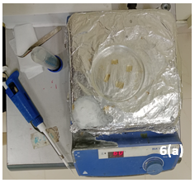 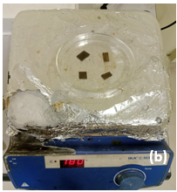

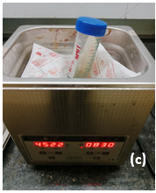

**Fig. 6: Fabrication process of device (a) Drop-casting of GO over glass substrate (b) Reduction of GO to rGO (c) Sonication of MoS2 solution**

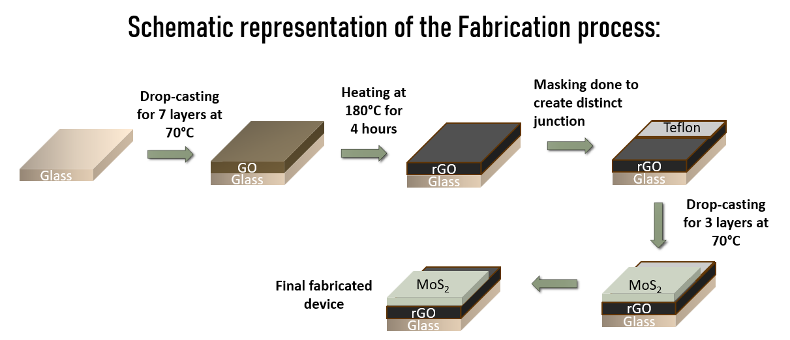

**7.1 Method of Deposition: Drop-casting:**

* **Simplicity:** Drop casting is a straightforward and low-cost deposition method requiring minimal equipment, making it ideal for laboratory-scale sensor fabrication.
* **Layer Control:** Allows controlled, sequential deposition of material layers (e.g., 7 layers of GO, 3 layers of MoS₂) to achieve desired film thickness and coverage.
* **Material Efficiency:** Enables direct deposition of small quantities of material without significant wastage, which is beneficial when working with expensive or limited-quantity 2D materials.
* **Scalability for Prototyping:** While not ideal for industrial-scale production, drop casting is effective for small-batch sensor prototyping and initial research purposes.

**7.2 Limitations:**

* **Non-uniform Film Formation:** Films can suffer from thickness variations, coffee-ring effects, or poor uniformity over larger areas due to solvent evaporation patterns.
* **Limited Precision:** Difficult to precisely control film morphology and layer thickness compared to advanced techniques like spin coating or spray deposition.
* **Slow Processing:** Requires sequential layer deposition and drying, which can be time-consuming for multi-layer structures.
* **Scalability Challenges:** Not suitable for large-scale or automated manufacturing without significant process optimization.

**8. STRUCTURAL AND MORPHOLOGICAL CHARACTERIZATION:**

Structural and morphological characterization of the fabricated rGO–MoS₂ sensor was carried out using X-ray diffraction (XRD) and Field Emission Scanning Electron Microscopy (FESEM) to verify material quality, uniformity, and heterojunction formation.

**8.1 X-ray Diffraction (XRD):**

X-ray Diffraction (XRD) is a fundamental technique used to determine the crystalline structure and phase purity of materials. It works on the principle of ***Bragg’s Law***, expressed as:

**nλ = 2d sinθ**

Where:

* *n* = order of reflection (usually 1)
* *λ* = wavelength of the incident X-rays
* *d* = interplanar spacing in the crystal
* *θ* = angle of diffraction (Bragg angle)

When X-rays interact with a crystalline material, they are diffracted at specific angles (2θ) corresponding to the atomic planes in the crystal lattice. Peaks in the XRD pattern represent these diffraction events and are characteristic of the material's crystal structure.

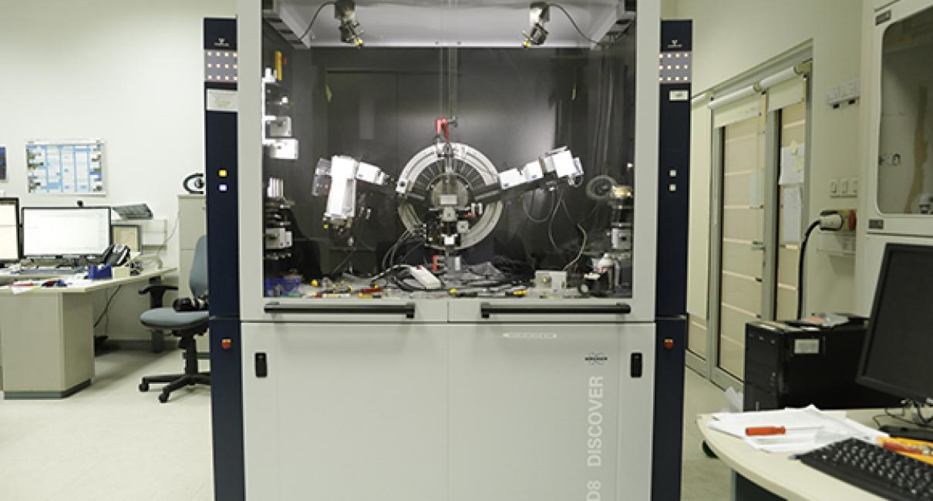

**Fig. 7: XRD set-up at IIT Bhubaneswar**

**For rGO and MoS₂ in my device:**

* **Reduced Graphene Oxide (rGO):**After reduction, the characteristic GO peak around ~11° (for GO) disappears, and a new broad peak typically appears near 24° to 26° (2θ). This shift indicates successful reduction and partial restoration of the graphitic structure.
* **Molybdenum Disulfide (MoS₂):**MoS₂ exhibits prominent peaks at specific 2θ angles, commonly around 14.4° (002 plane), which confirms its layered structure. Additional peaks may appear near 33°, 39°, and 58°, corresponding to higher-order reflections.

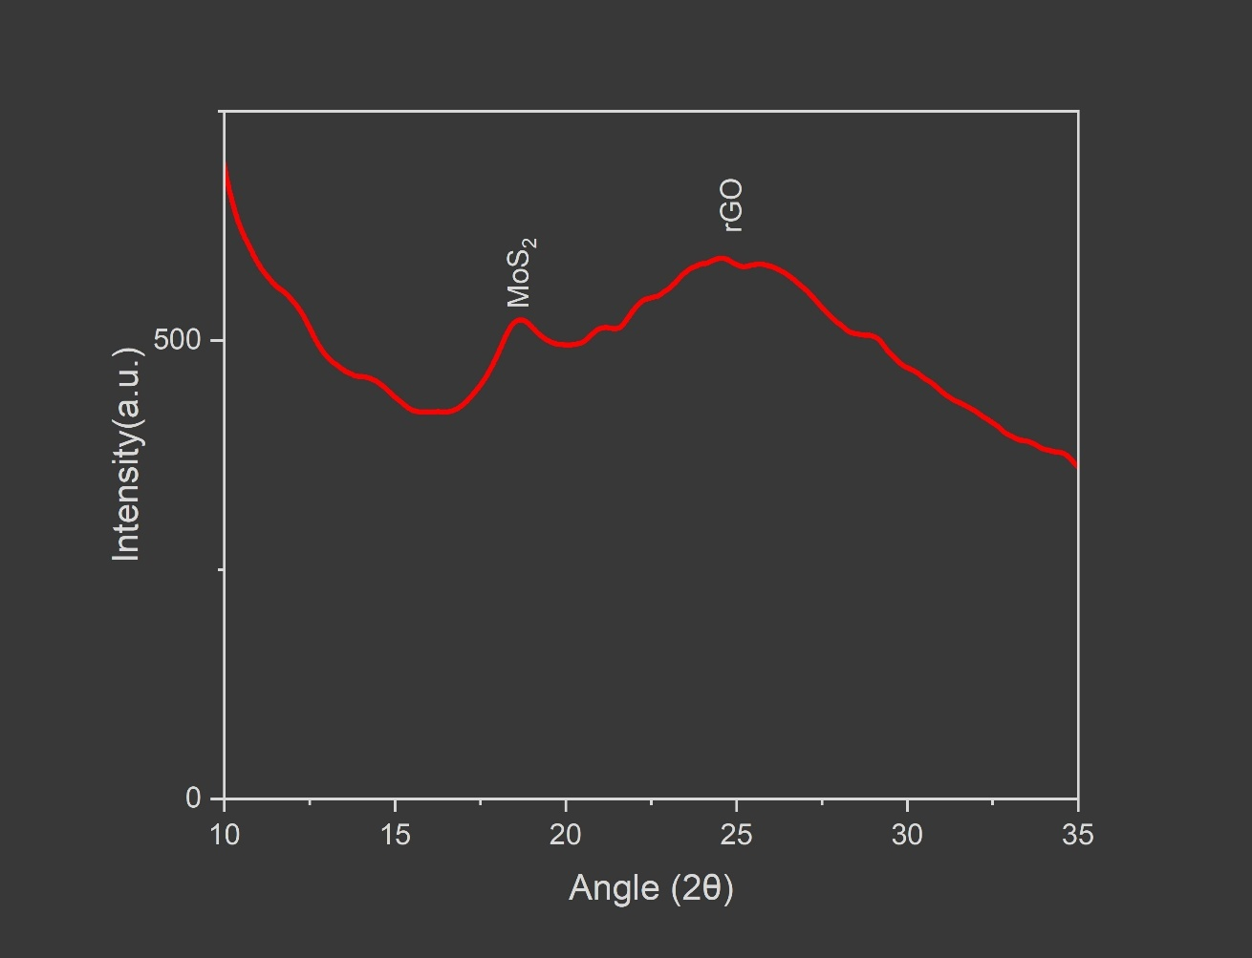

**Fig. 8: XRD Spectrum showing the formation of rGO-MoS2 Heterojunction phases**

**8.2 Field Emission Scanning Electron Microscopy (FESEM):**

Field Emission Scanning Electron Microscopy (FESEM) is a high-resolution imaging technique used to examine the surface morphology and microstructure of materials at the nanoscale. Unlike conventional SEM, FESEM uses a field emission electron source, which produces a finer electron beam with higher brightness and lower energy spread. This allows FESEM to generate extremely sharp, detailed images of surface structures.

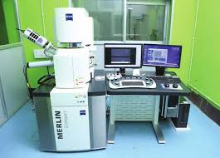

**Fig. 9: FESEM set-up at IIT Bhubaneswar**

In my sensor fabrication process, FESEM was crucial for visualizing the surface morphology and uniformity of the deposited layers:

* The **rGO** layer exhibited **nanoflake-like structures**, indicating successful exfoliation and reduction of GO with a uniform, conductive film formation.
* The **MoS₂** layer appeared as thin, **sheet-like nanosheets**, evenly distributed over the rGO surface, confirming proper deposition and good adhesion between the two layers.

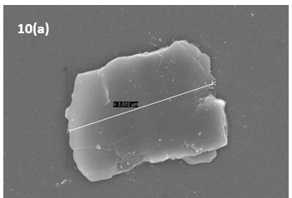 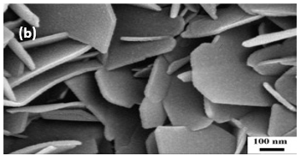

**Fig. 10: FESEM showing (a) rGO nano-flake (b) MoS2 nano-sheets**

Together, XRD and FESEM confirmed that the device possessed a uniform heterostructure with well-formed rGO and MoS₂ layers, critical for effective sensor operation.

**9. ELECTRICAL CHARACTERIZATION:**

Electrical characterization of the fabricated rGO–MoS₂ heterojunction sensor was conducted using a **four-probe cryogenic probing station** to analyse its current-voltage (I–V) behaviour, which was measured with the help of a **Source-Measure Unit (SMU)** and **Keysight Quick I-V** software to assess its sensing capability.

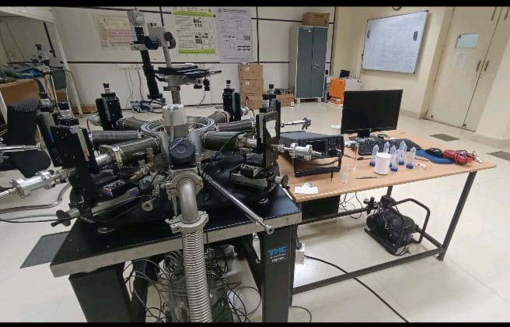

**Fig. 11: Cryogenic Probing Station at IIT Bhubaneswar**

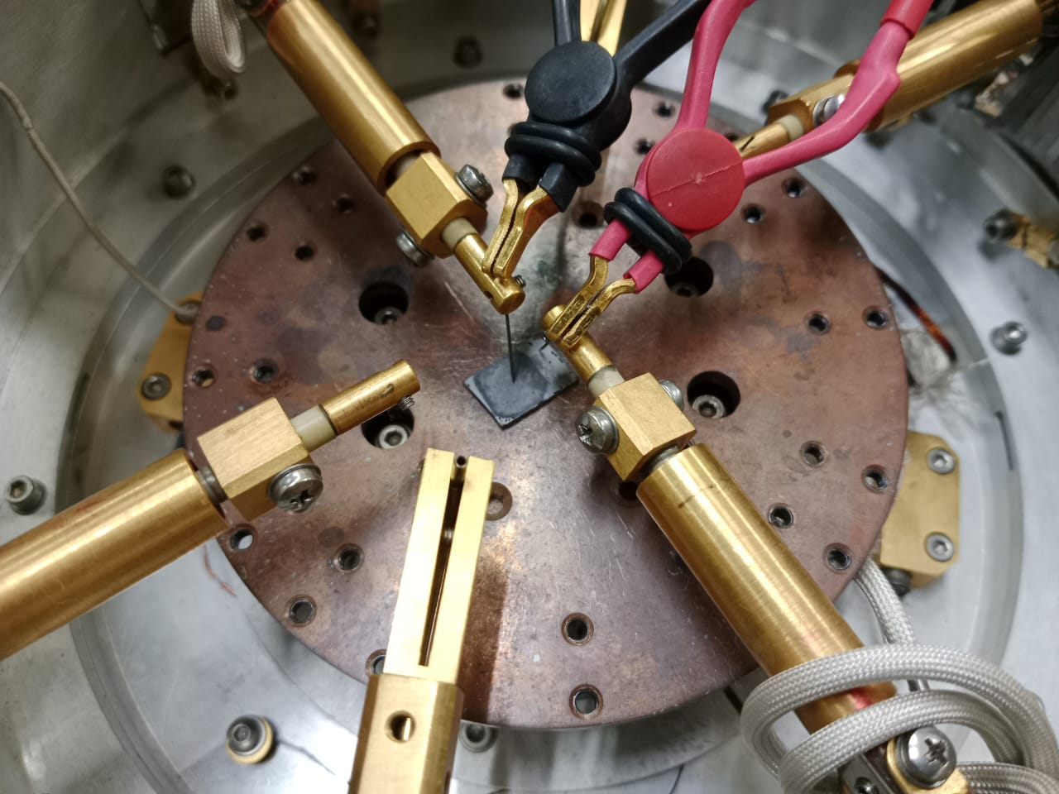 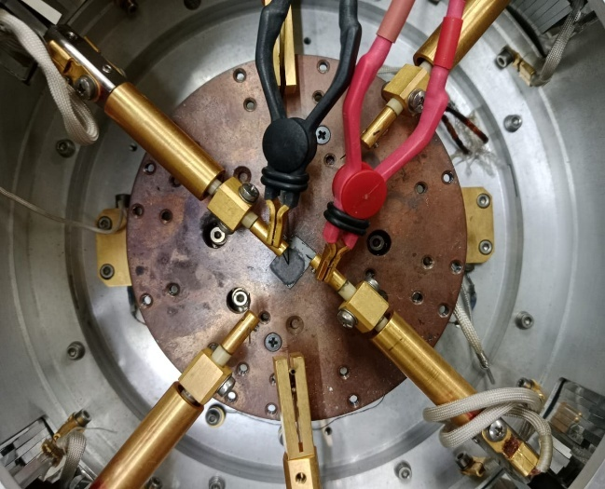

**Fig. 12: Probing of the Heterojunction-based device**

* **Two-Probe Method:**  
  This technique eliminates contact resistance errors by using separate probes for current supply and voltage measurement. It ensures accurate assessment of the device’s intrinsic electrical properties.
* **Measurement Conditions:**  
  Characterization was performed under controlled temperature conditions using a cryogenic probing station, allowing precise low-temperature and room-temperature measurements to evaluate the device’s response under varying conditions.
* **Observed I–V Characteristics:**The device exhibited **Schottky-type I–V curves**, characteristic of a heterojunction due to difference in band gap of rGO and MoS2, confirming the formation of a p–n junction between the conductive p-type rGO layer and semiconducting n-type MoS₂ layer.

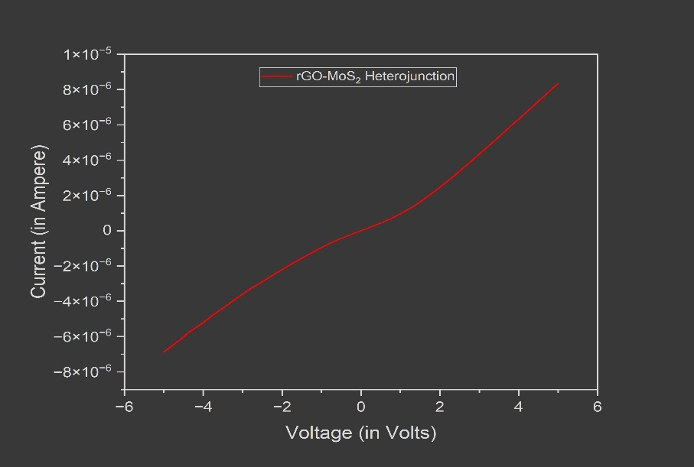

**Fig. 13: I-V characteristic curve of the device**

**9.1 Heavy Metal-Ion Detection:**

This device was subjected to different metal ions – Nickel, Cadmium, Mercury, Lead and Copper at different concentration levels to find out the response of the device.

**1. Nickel (Ni2+):**

|  |  |
| --- | --- |
| **Response (%)** | **Concentration (ppm)** |
| 9.76955 | 0.1 |
| 5.05837 | 1 |
| 4.3202 | 20 |
| 4.7326 | 40 |

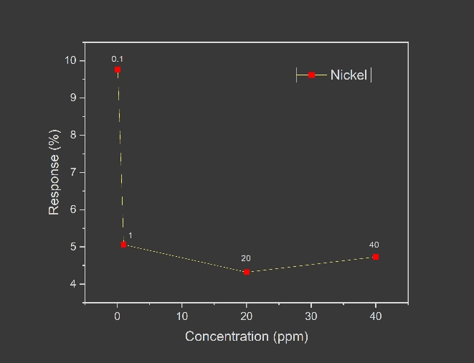

**2. Cadmium (Cd2+):**

|  |  |
| --- | --- |
| **Concentration (ppm)** | **Response (%)** |
| 0.01 | 69.27701 |
| 0.1 | 40.79505 |
| 10 | 34.88542 |
| 20 | 30.38776 |
| 30 | 36.31933 |

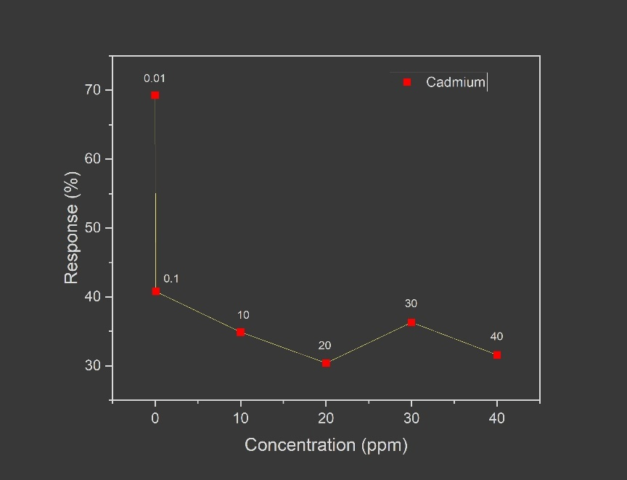

**3. Mercury (Hg2+):**

|  |  |
| --- | --- |
| **Concentration (ppm)** | **Response (%)** |
| 0.01 | 0.70629 |
| 0.1 | 1.89833 |
| 1 | 2.68594 |
| 20 | 5.08004 |
| 30 | 7.87453 |

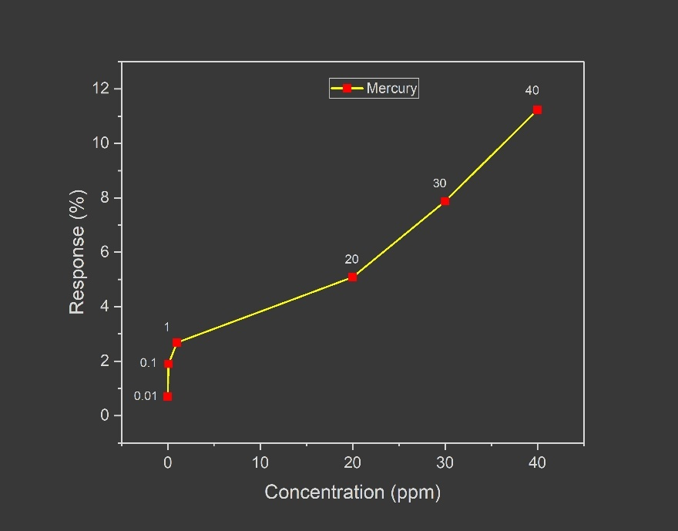

**4. Lead (Pb2+):**

|  |  |
| --- | --- |
| **Concentration (ppm)** | **Response (%)** |
| 0.01 | 1.15323 |
| 0.1 | 3.45986 |
| 1 | 3.64514 |
| 10 | 10.98734 |
| 20 | 30.3239 |

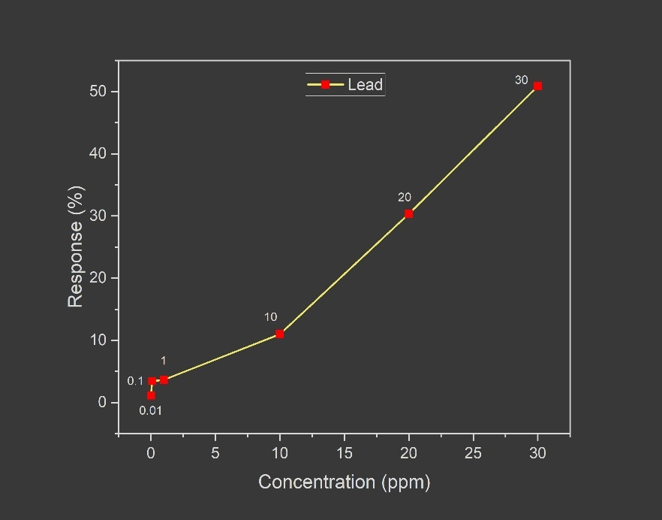

**5. Copper (Cu2+):**

|  |  |
| --- | --- |
| **Concentration (ppm)** | **Response (%)** |
| 0.01 | 2.11703 |
| 0.1 | 6.11697 |
| 1 | 40.21484 |
| 10 | 135.36316 |
| 20 | 78.41156 |

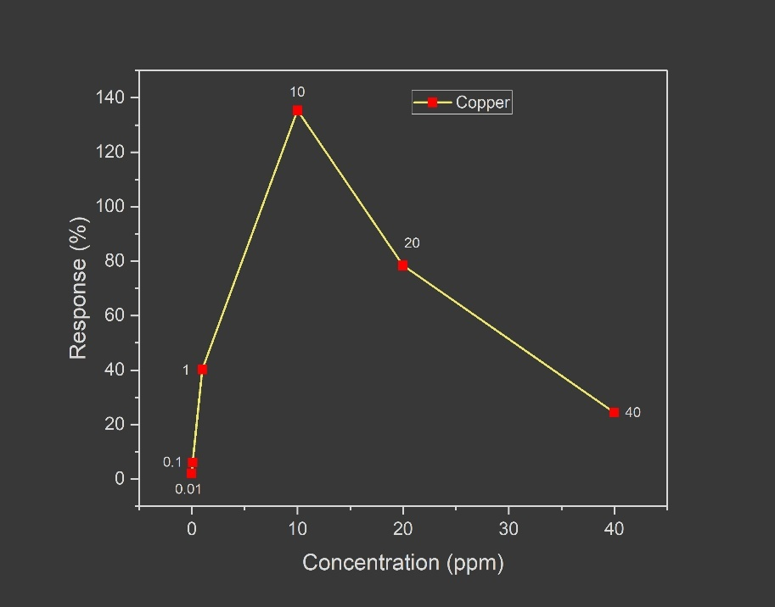

**10. CONCLUSION:**

In this project, an rGO–MoS₂ based conductometric sensor was successfully developed for selective detection of heavy metal ions in drinking water. High-quality rGO and MoS₂ nanosheets were synthesized and sequentially assembled into a heterojunction structure using a simple drop-casting method. Structural integrity and uniform layer formation were confirmed through XRD and FESEM analysis, while electrical characterization demonstrated the formation of a stable p–n junction critical for sensing performance. The sensor exhibited **selective sensitivity towards Pb²⁺ (lead ions)** compared to other tested metal ions, making it particularly effective for monitoring lead contamination in water.

Notably, the sensor’s response improved progressively with increasing lead ion concentration, showing a clear, quantifiable trend. The response reached over **50% at 30 ppm concentration of Pb²⁺**, indicating good sensitivity even at relatively low concentrations. This performance highlights the sensor’s potential for real-time, selective lead detection in contaminated water, contributing to public health and environmental monitoring applications.

**11. FUTURE SCOPE OF WORK:**

* **Detailed Study of Sensing Mechanism:**  
  Further investigation into the charge transfer processes and interface interactions within the rGO–MoS₂ heterojunction is required to fully understand the sensing mechanism, particularly in the presence of Pb²⁺ ions.
* **Improving Reliability and Reproducibility:**  
  The sensor's fabrication process needs to be optimized to ensure batch-to-batch consistency and long-term operational stability under various environmental conditions.
* **VOC Sensing Using the Same Device:**  
  Exploring the device's ability to detect volatile organic compounds (VOCs) will broaden its application range, leveraging the high surface activity of MoS₂ for gas-phase sensing.
* **Extending Sensing Range and Selectivity:**  
  Research should focus on enhancing the sensitivity and selectivity of the sensor for detecting other heavy metals and pollutants, possibly through surface functionalization or material modifications.
* **Device Miniaturization and Integration:**  
  Developing flexible or portable sensor formats and integrating them into real-time monitoring systems could facilitate field deployment for continuous water quality assessment.

By addressing these aspects, the rGO–MoS₂ sensor can be further advanced into a versatile, multi-functional sensing platform suitable for environmental and industrial applications.

**12. LIMITATIONS:**

The developed rGO–MoS₂ heterojunction sensor, while demonstrating promising results for lead ion detection, has certain limitations that need to be addressed before practical large-scale deployment.

* **Limited Long-Term Stability:**  
  Device performance may degrade over time due to material degradation or environmental exposure, affecting sensor reliability.
* **Batch-to-Batch Variability:**  
  Manual drop-casting can lead to inconsistencies in layer thickness and junction quality, impacting reproducibility between devices.
* **Limited Selectivity Beyond Lead Ions:**  
  While selective to Pb²⁺ ions, the current sensor configuration shows limited selectivity towards other heavy metal ions without further surface modifications.
* **Sensitivity to Environmental Conditions:**  
  Humidity, temperature fluctuations, and surrounding chemical interferences may affect sensor response.
* **Scalability Challenges:**  
  Drop-casting, while simple, is not ideal for large-scale or automated production without process optimization.

**13. REFERENCES:**

[1] Abid, Poonam Sehrawat, S. S. Islam, Prabhash Mishra, and Shahab Ahmad. "Reduced graphene oxide (rGO) based wideband optical sensor and the role of Temperature, Defect States and Quantum Efficiency." *Scientific reports* 8, no. 1 (2018): 3537.

[2] Khan, Zaheen U., Ayesha Kausar, Hidayat Ullah, Amin Badshah, and Wasid U. Khan. "A review of graphene oxide, graphene buckypaper, and polymer/graphene composites: Properties and fabrication techniques." *Journal of plastic film & sheeting* 32, no. 4 (2016): 336-379.

[3] Novoselov, Konstantin S., Luca Colombo, P. R. Gellert, M. G. Schwab, and K. A. J. N. Kim. "A roadmap for graphene." *nature* 490, no. 7419 (2012): 192-200.

[4] Ren, Wencai, and Hui-Ming Cheng. "The global growth of graphene." *Nature nanotechnology* 9, no. 10 (2014): 726-730.

[5] Gao, Wei, Mainak Majumder, Lawrence B. Alemany, Tharangattu N. Narayanan, Miguel A. Ibarra, Bhabendra K. Pradhan, and Pulickel M. Ajayan. "Engineered graphite oxide materials for application in water purification." *ACS applied materials & interfaces* 3, no. 6 (2011): 1821-1826.

[6] Vashisht, Devika, Ekta Sharma, Manpreet Kaur, Aseem Vashisht, S. K. Mehta, and Kulvinder Singh. "Solvothermal assisted phosphate functionalized graphitic carbon nitride quantum dots for optical sensing of Fe ions and its thermodynamic aspects." *Spectrochimica Acta Part A: Molecular and Biomolecular Spectroscopy* 228 (2020): 117773.

[7] Mahalik, Sukanya, K. Akshay, and Sayan Dey. "A 2D-MoS2 Based Thin-Film Transistor for Trace-Level SO2 Monitoring." *IEEE Transactions on Electron Devices* (2024).

[8] Kar, Anurag, Sayan Dey, Debasree Burman, Sumita Santra, and Prasanta Kumar Guha. "RGO/Ni 2 O 3 Heterojunction-Based Reusable, Flexible Device for Cr (VI) Ion Detection in Water." *IEEE Transactions on Electron Devices* 68, no. 2 (2021): 780-785.

[9] Pattra, Arijit, Saumodip Das, Mousiki Kar, and Sayan Dey. "Graded junction ZnO on rGO conduction layer for ultra selective Cu (II) ion detection." *IEEE Sensors Journal* (2024).

[10] Zhou, Yong, Guoqing Liu, Xiangyi Zhu, and Yongcai Guo. "Ultrasensitive NO2 gas sensing based on rGO/MoS2 nanocomposite film at low temperature." *Sensors and Actuators B: Chemical* 251 (2017): 280-290.

[11] Tu, N. D. K., Choi, J., Park, C. R., & Kim, H.. Remarkable conversion between n-and p-type reduced graphene oxide on varying the thermal annealing temperature. *Chemistry of Materials*, *27*(21), 7362-7369 (2015).

[12] Miller, Derek R., Sheikh A. Akbar, and Patricia A. Morris. "Nanoscale metal oxide-based heterojunctions for gas sensing: A review." *Sensors and Actuators B: Chemical* 204 (2014): 250-272.